Coleridge Families Minutes 16 November 2020 (by Zoom)

Present:
Andrew Day, Elizabeth Mackie, Joanna Shakhmin, Ayla Us, Cindy Dos Santos, Georgia Norton, Leon Choueke, Marielle Drier, Melanie Solomou, Victoria Roberts, Cristina Aldea, James Merryweather, Kai Simmons, Victoria Roberts

Elizabeth Mackie
The meeting started with a Thank You to outgoing Chair Liz Mackie who has done so much for Coleridge Families, and the school, over the last decade. She has contributed a huge amount in leadership and dedicated hard work.

Mr Choueke’s update
As announced to parents, there will be another large phase of playground rebuilding over the summer. CF will have a role afterwards in helping to fill some remaining spots.
The school is planning a drive to create a whole-school culture of reading. Mr Choueke would like CF to think about ways it can contribute to getting families to read. This could include some events around books or authors.
Mr Choueke also mention that he’d been touched by how much enthusiasm there was among parents/carers to help out in the face of the cancellations and staff shortages over the last few weeks – could we reach out and tap some of this?
There was some discussion of helping further with the reading spaces (possibly inspired by this picture of Discovery Stratford:
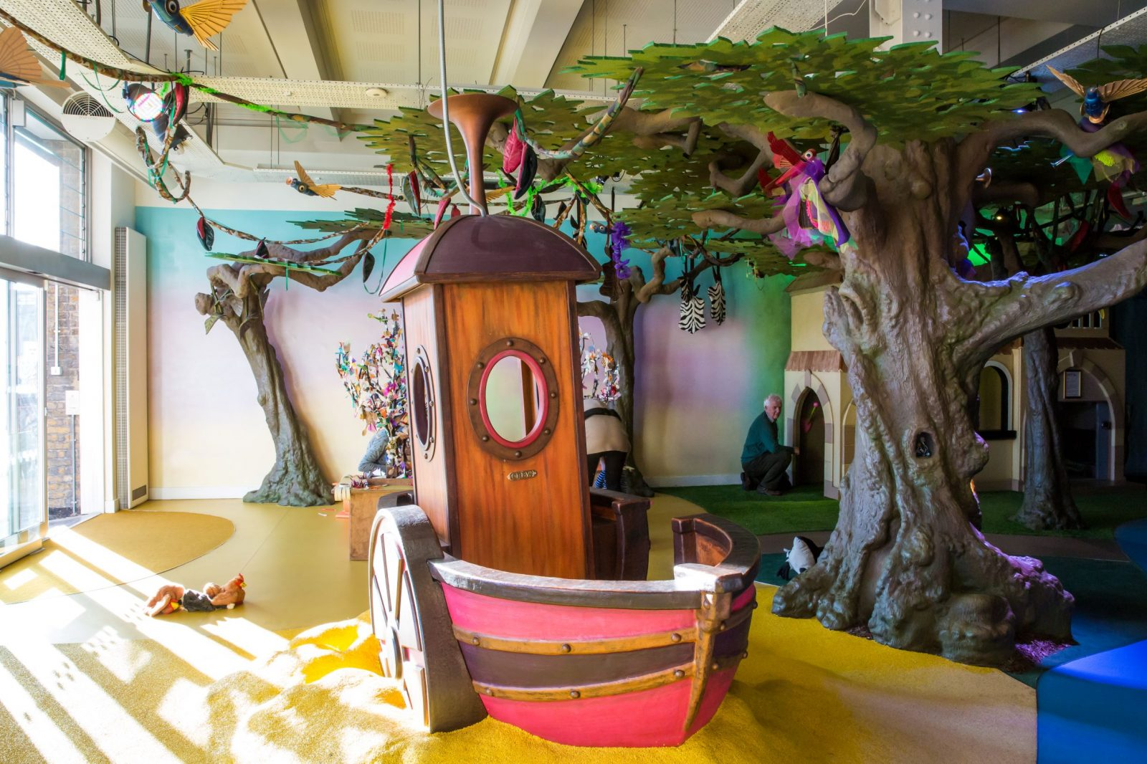

Merchandising
Victoria reported that the Sale has generated activity. The process to purchase, however, seems to be a little offputting. However, she will be able to update us more fully next time. The idea of more products that are tie-ins to other Coleridge Families activity (e.g. an apron on offer at the same time as the recipe book) might be worth looking into.

Ticket Tailor
Liz reported that Ticket Tailor is now significantly more expensive than it used to be and is not a good option for us now. She said she would try to contact them and point this out in the hope that they may adjust the rate. Otherwise a new platform needs to be found. Perhaps the merchandising site we are using could cover some of the things that we currently use TT for.

Road Closure
In September Haslemere Road and Waverly Road will be closed to traffic at drop-off/pick-up times. Georgia pointed out that CF might help to spread the positive message (less pollution and congestion) as there may be some disgruntled drivers. (Especially those who are unaware of the changes and then receive fines).

New Treasurers
The following people were appointed as Coleridge Families Treasurers:
Kai Simmons
James Merryweather
Cristina Aldea

A Day
November 2020

